Jennifer DeVore

10 March 2020

CIS 435

**Unit 2 Graded Exercise 1: Retrieve Data from two or more Tables**

1. **Write a SELECT statement that returns all columns from the Vendors table inner-joined with the Invoices table.**

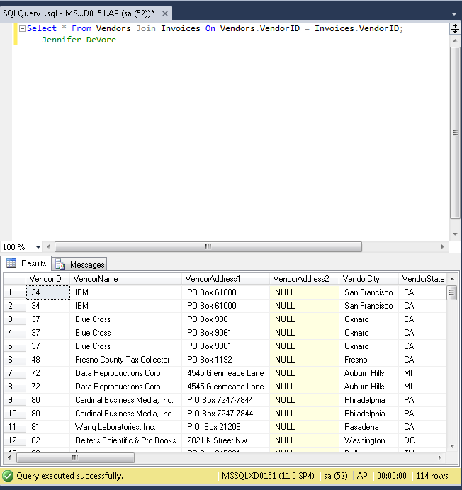

**2. Write a SELECT statement that returns four columns: VendorName InvoiceNumber InvoiceDate Balance From the Vendors table From the Invoices table From the Invoices table InvoiceTotal minus the sum of PaymentTotal and CreditTotal The result set should have one row for each invoice with a non-zero balance. Sort the result set by VendorName in ascending order.**

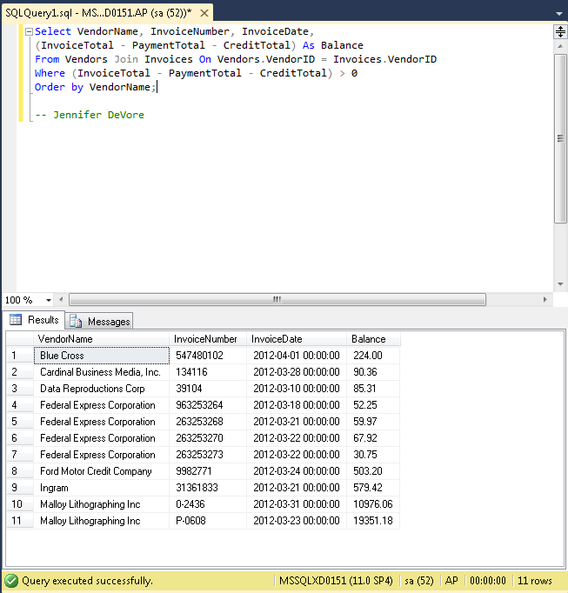

**3. Write a SELECT statement that returns three columns: VendorName DefaultAccountNo AccountDescription From the Vendors table From the Vendors table From the GLAccounts table The result set should have one row for each vendor, with the account number and account description for that vendor’s default account number. Sort the result set by AccountDescription, then by VendorName.**

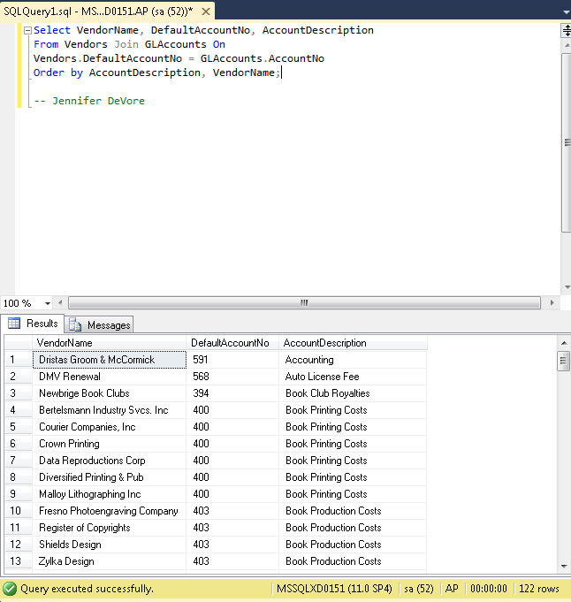

**4. Generate the same result set described in exercise 2, but use the implicit join syntax.**

